**ABOUT ME**

**1. What SITUATIONS give me the most trouble? List any 3.**

1.1. **Public Speaking:** I feel nervous when I have to speak in front of a group of people.  
1.2. **Networking Events:** Meeting new people can be overwhelming for me, and I often don't know how to start a conversation.  
1.3. **Job Interviews:** The pressure to impress interviewers makes me anxious, and I worry about answering questions correctly.

**WHY do these situations trouble me?**

1.1. **Fear of Judgment:** I worry about what others will think of me when I speak, which makes me anxious.  
1.2. **Social Anxiety:** I often feel shy and believe people might not like me, making it hard to engage.  
1.3. **Performance Pressure:** I feel like I need to do really well in interviews, which creates a lot of stress for me.

**2. What sort of PEOPLE make me feel that I lack confidence? List any 3.**

2.1. **Very Outgoing People:** Their confidence and energy can make me feel shy and less interesting.  
2.2. **Highly Accomplished Individuals:** Being around people who have achieved a lot makes me doubt my own abilities.  
2.3. **Critical People:** When someone is overly critical, it lowers my self-esteem and makes me feel inadequate.

**WHY?**  
I feel this way because:

* **Comparison:** I tend to compare myself to others and feel I don't measure up.
* **Insecurity:** Their confidence highlights my own doubts, making me feel even more insecure.
* **Fear of Criticism:** I worry about being judged, which makes me hesitant to express myself.

**3. What SITUATION(S) would I like to master? Why?**  
I would like to master **public speaking**, **networking**, and **job interviews**. These skills are important for my career development and will help me feel more confident in my professional life.

**4. What situations am I particularly GOOD at?**  
I am particularly good at:

* **Working in Teams:** I enjoy collaborating with others and can contribute positively to group projects.
* **Problem Solving:** I love tackling challenges and finding effective solutions.
* **Listening:** I am a good listener, which helps me understand and support my peers.

**5. What is the ONE thing that I would like to CHANGE about my appearance/personality?**  
I would like to become more **confident** in social situations and interactions with others.

**6. How do I describe myself to people?**  
I describe myself as **thoughtful, creative, and friendly**. I enjoy helping others and love to learn new things.

**7. How will my FAMILY & FRIENDS describe me?**  
My family and friends would describe me as **kind, supportive, and dependable**. They know they can count on me when they need help or someone to talk to.

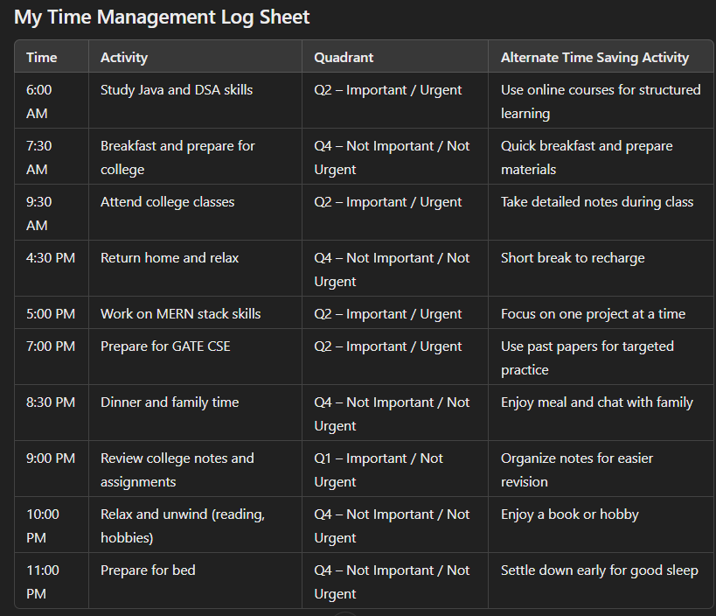

### My Quadrant Analysis

#### **Q1 – Important / Not Urgent**

* Activities that are essential but do not have immediate deadlines.
  + **Examples:**
    - Review college notes and assignments

#### **Q2 – Important / Urgent**

* Activities that are crucial and require immediate attention.
  + **Examples:**
    - Study Java and DSA skills
    - Attend college classes
    - Work on MERN stack skills
    - Prepare for GATE CSE

#### **Q3 – Not Important / Urgent**

* Activities that may feel urgent but do not significantly contribute to your goals. (You can adjust this if needed.)

#### **Q4 – Not Important / Not Urgent**

* Activities that are neither urgent nor important. They can be reduced or enjoyed in moderation.
  + **Examples:**
    - Breakfast and prepare for college
    - Return home and relax
    - Dinner and family time
    - Relax and unwind (reading, hobbies)
    - Prepare for bed

### My Goals Work-page

| **Period** | **Area** | **Goal** | **Action Step** | **Target Date** | **Proposed Evidence** |
| --- | --- | --- | --- | --- | --- |
| **This Year** | Academic | Improve Java and DSA skills | Study for 2 hours daily and complete online courses | By May 2025 | Completed online course certificate and practice problems |
|  | Social | Make new friends in college | Attend college events and participate in clubs | Ongoing | Number of new friends made and club participation |
|  | Health | Maintain a balanced diet and exercise regularly | Prepare healthy meals and exercise 4 times a week | Ongoing | Weekly meal plan and exercise log |
|  | Family | Spend more quality time with family | Organize weekly family dinners or outings | Ongoing | Family activity log and photos |
|  | Personal | Read 12 books this year | Read 1 book per month | By December 2024 | List of completed books with summaries |
|  | Career | Secure an internship in the tech industry | Apply to at least 5 internships and network | By July 2025 | Confirmation of internship offer |
| **Final Year** | Academic | Achieve a GPA of 8.5 or higher | Focus on studies, complete assignments on time | By May 2026 | GPA report card |
|  | Social | Build a strong professional network | Attend networking events and connect on LinkedIn | Ongoing | Number of connections made |
|  | Health | Run a 5K marathon | Follow a training plan and participate in a local marathon | By December 2025 | Registration and completion certificate |
|  | Family | Support younger siblings with their studies | Help them with homework and study sessions | Ongoing | Feedback from siblings and parents |
|  | Personal | Improve public speaking skills | Join a public speaking club or practice regularly | By March 2025 | Participation in speaking events and feedback |
|  | Career | Land a full-time job after graduation | Prepare resume, apply to jobs, and attend interviews | By June 2026 | Job offer letter and acceptance |

### A. Jeevan Yatra (Based on Class Activity)

**Where do you see yourself from now?**

| **Time Frame** | **Vision** |
| --- | --- |
| **In One Year** | Completing my B.Tech degree, gaining skills in Java, DSA, and MERN stack, and securing a summer internship in the tech industry. |
| **In Two Years** | Graduating with a high GPA, having practical experience through internships, and being active in college clubs and networking events. |
| **In Five Years** | Working as a software developer at a reputed tech company, contributing to innovative projects, and pursuing certifications in advanced technologies. |
| **In Ten Years** | Leading a team in a tech company, mentoring juniors, and possibly starting my own tech startup focused on solving real-world problems. |

### B. Stakeholders and Their Genuine Expectations

| **Sn. No.** | **Name of the Stakeholder** | **Genuine Expectation/s from You** |
| --- | --- | --- |
| 1 | Country | Contribute to technological advancements and innovations that benefit society. |
| 2 | Society | Engage in community service and help in addressing local issues through technology. |
| 3 | School | Maintain a positive attitude, achieve good grades, and participate in extracurricular activities. |
| 4 | University | Excel in academics, represent the university in competitions, and contribute to research projects. |
| 5 | Parents | Focus on my studies, maintain good values, and secure a stable job after graduation. |
| 6 | Self | Continually improve my skills, pursue my passions, and strive for personal and professional growth. |

### C. My Vision Statement

**Reason for Existence – How would you be remembered?**  
I want to be remembered as an innovative software developer who used technology to solve real-world problems, positively impacting society and inspiring others to pursue their passions.

### My Mission Statement – My Guidelines for Achieving My Vision

a. **Commit to continuous learning** in programming and technology to stay updated with industry trends.  
b. **Engage in teamwork and collaboration** to build strong relationships and enhance my skills.  
c. **Contribute to community service projects** that use technology to improve lives and address societal issues.

### My Mantra in Life

"Stay curious and keep learning every day. Embrace challenges as opportunities for growth and believe in yourself to turn dreams into reality."

### D - My Goal

#### 1. Where do I see my placement on completion of degree?

**SMART GOAL:**

* **Company:** Google
* **Salary:** ₹10,00,000 per annum
* **Location:** Bangalore
* **Designation:** Software Engineer
* **Action Steps:**
  + Build a strong portfolio showcasing my MERN stack projects and Java applications.
  + Network with industry professionals through LinkedIn and college events.
  + Prepare for coding interviews by practicing algorithms and data structures regularly.

#### 2. VACATIONS GOAL: Dec 2024 (Project/Internship)

**SMART GOAL:**

* **Company:** Microsoft
* **Stipend:** ₹30,000 per month
* **Location:** Hyderabad
* **Key Points of Internship:**
  + Work on developing a web application using the MERN stack, focusing on front-end and back-end integration.
  + Participate in team meetings to enhance my collaboration skills.
  + Receive mentorship from experienced software engineers to improve my coding practices.

#### 3. GOAL: June 2025 (Project/Internship)

**SMART GOAL:**

* **Company:** Amazon
* **Stipend:** ₹40,000 per month
* **Location:** Bangalore
* **Key Points of Internship:**
  + Focus on cloud computing projects using AWS, leveraging my knowledge of back-end development.
  + Assist in building scalable applications while learning about microservices architecture.
  + Present my project progress during weekly team meetings to enhance my communication skills.

#### 4. GOAL: Dec 2025 (Project/Internship)

**SMART GOAL:**

* **Company:** IBM
* **Stipend:** ₹35,000 per month
* **Location:** Gurgaon
* **Key Points of Internship:**
  + Engage in AI and machine learning projects, utilizing my understanding of algorithms and data structures.
  + Work with data analytics to gain insights into real-world problems.
  + Collaborate with a diverse team to learn about different approaches to problem-solving.

### PRESENTATION

|  | **EMERGING (0-25%)** | **DEVELOPING (25%-75%)** | **MASTERY (75%-100%)** |
| --- | --- | --- | --- |
| RELEVANCE/KNOWLEDGE OF CONTENT |  | ✔️ |  |
| ORIGINALITY OF CONTENT |  | ✔️ |  |
| TIME TAKEN | ✔️ |  |  |
| COMMUNICATION SKILLS |  | ✔️ |  |
| BODY LANGUAGE |  | ✔️ |  |

### E - MY SWOT Analysis

| **Strengths** | **Weaknesses** |
| --- | --- |
| Strong programming skills in Java and DSA | Need to improve public speaking skills |
| Quick learner, especially in new technologies | Time management under pressure |
| Dedicated and disciplined in studies | Limited real-world project experience |

| **Opportunities** | **Threats** |
| --- | --- |
| Internship opportunities in tech companies | High competition for placements |
| Growing demand for software developers | Rapidly changing technology landscape |
| Networking with industry professionals | Economic downturn affecting job market |

### STUDENTS

|  | **EMERGING (0-75%)** | **DEVELOPING (75-90%)** | **MASTERY (90-100%)** |
| --- | --- | --- | --- |
| ATTENDANCE |  | ✔️ |  |
| REGULARITY IN SUBMISSION |  | ✔️ |  |
| COMMUNICATION SKILLS |  | ✔️ |  |
| MAINTENANCE OF WORK RECORDS |  |  | ✔️ |
| RESULTS OF ASSESSMENT |  |  | ✔️ |

**F) My Abilities (1-9 Scale)**

| **Sn. No** | **Ability** | **Score (1-9)** | **Reference (Online Mock/Internal Aptitude Test)** |
| --- | --- | --- | --- |
| I | Number aptitude | 7 | [Reference test link] |
| II | Verbal comprehension | 6 | [Reference test link] |
| III | Perceptual speed | 5 | [Reference test link] |
| IV | Reasoning | 8 | [Reference test link] |
| V | Spatial visualization | 5 | [Reference test link] |
| VI | Computational | 9 | [Reference test link] |

**My Skills (1-9 Scale)**

| **Sn. No** | **Skill** | **Certification Name (Grade) / Project** |
| --- | --- | --- |
| 1 | Java | Completed “Core Java Bootcamp from Zero to Hero” (A+) |
| 2 | DSA | LinkedIn Certificate in Data Structures and Algorithms (A) |
| 3 | MERN Stack | Ongoing personal project for developing web applications |
| 4 | HTML & CSS | Completed “Learn HTML and CSS from Beginning to Advanced” (A+) |
| 5 | JavaScript | Completed “JavaScript Masterclass for Beginner to Expert” (A+) |

**My Personality Traits (Reference 16 PF/ MBTI)**

| **Sn. No** | **Trait** | **One Incident (of any 4 you wish to highlight during the interview)** |
| --- | --- | --- |
| 1 | Analytical | Solved complex DSA problems in my coding challenge, demonstrating strong analytical skills. |
| 2 | Communicative | Led a discussion during a group project presentation in college, effectively conveying ideas to team members. |
| 3 | Adaptable | Adjusted to new programming languages quickly while working on different projects, showcasing adaptability. |
| 4 | Detail-oriented | Paid attention to every detail when designing my Online Library Management System, ensuring a smooth user experience. |
| 5 | Collaborative | Collaborated effectively in organizing a successful hackathon event, showcasing teamwork and collaboration skills. |
| 6 | Goal-oriented | Set clear targets for my studies and consistently worked towards achieving them, leading to successful outcomes. |

**My Values (Reference Rokeach Survey)**

**My Terminal Value:**

* **Success:** Achieving personal and professional goals while making a positive impact on society.

**My Instrumental Values (Top 5):**

1. **Integrity:** Always maintaining honesty and transparency in my work.
2. **Hard Work:** Dedicating effort and time to achieve my goals.
3. **Learning:** Continuous self-improvement and acquiring new knowledge.
4. **Teamwork:** Valuing collaboration and supporting my peers.
5. **Innovation:** Embracing creativity and seeking new solutions to problems.

**G) Detailed Plan for Achieving My SMART Goal**

**SMART Goal:** Secure a placement at a reputable software company with a salary of INR 8 LPA or more by June 2025.

**Detailed Plan:**

1. **Specific:**
   * Target companies: Google, Microsoft, or any leading tech firm.
   * Desired position: Software Developer or Full-Stack Developer.
2. **Measurable:**
   * Complete at least three relevant internships by June 2025.
   * Achieve an average of 75% or above in my coursework related to programming and software development.
3. **Achievable:**
   * Utilize my existing skills in Java, DSA, and MERN stack to build a strong portfolio.
   * Attend workshops and webinars for industry insights and networking.
4. **Relevant:**
   * Align my learning and projects with the skills demanded in the job market, focusing on software development and emerging technologies.
5. **Time-bound:**
   * Complete my targeted internships by December 2024.
   * Finalize my portfolio and apply for placements by April 2025.

**Action Steps:**

* **Daily:** Dedicate 2 hours each morning for skill enhancement (Java, DSA).
* **Weekly:** Work on MERN stack projects every Saturday and Sunday.
* **Monthly:** Attend at least one tech event or hackathon to network and gain exposure.
* **By June 2025:** Regularly apply for jobs and prepare for interviews.

### Skills Evaluation

| **Skill** | **Emerging (0-25%)** | **Developing (25-75%)** | **Mastery (75-100%)** | **Comments/Examples** |
| --- | --- | --- | --- | --- |
| **SPOKEN SKILLS (50)** |  |  |  |  |
| - Fluency |  | ✅ (60%) |  | Able to express ideas clearly, though needs practice. |
| - Pronunciation |  | ✅ (70%) |  | Generally clear, but occasionally mispronounces words. |
| - Vocabulary |  | ✅ (65%) |  | Good range but could expand further with reading. |
| - Voice Modulation |  | ✅ (60%) |  | Uses modulation effectively but can improve variety. |
| - Content |  | ✅ (75%) |  | Relevant and well-structured arguments in discussions. |
|  |  |  |  |  |
| **RESUME WRITING (40)** |  |  |  |  |
| - Content |  | ✅ (70%) |  | Strong content but can be more concise. |
| - Presentation |  | ✅ (60%) |  | Visually appealing but needs formatting adjustments. |
| - Approach |  | ✅ (75%) |  | Good approach tailored for tech positions. |
| - Objective |  | ✅ (80%) |  | Clearly stated goals aligning with career aspirations. |
|  |  |  |  |  |
| **BOOK REVIEW (30)** |  |  |  |  |
| - Content |  | ✅ (70%) |  | Comprehensive reviews but could include more insights. |
| - Originality |  | ✅ (75%) |  | Unique perspectives on themes and characters. |
| - Presentation |  | ✅ (65%) |  | Generally well-organized but needs clearer structure. |
|  |  |  |  |  |
| **GROUP DISCUSSION (40)** |  |  |  |  |
| - Involvement |  | ✅ (75%) |  | Actively participates, shares ideas confidently. |
| - Active Listening |  | ✅ (70%) |  | Good listener but sometimes interrupts. |
| - Content/Knowledge |  | ✅ (80%) |  | Strong grasp of subject matter; contributes effectively. |
| - Time Management |  | ✅ (75%) |  | Generally stays within time limits. |
|  |  |  |  |  |
| **BODY LANGUAGE (20)** |  |  |  |  |
| - Posture |  | ✅ (75%) |  | Generally maintains good posture during speaking. |
| - Hand Gestures |  | ✅ (70%) |  | Uses gestures to emphasize points, needs refinement. |
|  |  |  |  |  |
| **PRESENTATION (60)** |  |  |  |  |
| - Content |  | ✅ (75%) |  | Well-researched and relevant content. |
| - Originality |  | ✅ (70%) |  | Creative approach in delivering presentations. |
| - PPT Visibility, Clarity & Organization |  | ✅ (80%) |  | Clear and well-organized slides, visually appealing. |
| - References |  | ✅ (75%) |  | Cited sources correctly but can include more recent data. |
| - Time Limit |  | ✅ (70%) |  | Mostly adheres to time limits; slight overruns sometimes. |
| - Confidence in Answering Questions |  | ✅ (80%) |  |  |